CHEMICAL ENGINEERING TRANSACTIONS  VOL. , 2023 | A publication of
The Italian Association
of Chemical Engineering
Online at www.cetjournal.it

Guest Editors:
Copyright © 2023, AIDIC Servizi S.r.l.
ISBN 979-12-81206-XX-X; ISSN 2283-9216

Comparison of Novel and Commercial Catalysts for the Steam Reforming of Tar Obtained from Biomass Gasification
Andrea Di Carloª, Alessandro Antonio Papaª*, Manfred Nacken^{b}
ª Dipartimento di Ingegneria Industriale dell’Informazione e di Economia, Università degli Studi dell’Aquila, Piazzale E.
Pontieri 1, Monteluco di Roio, 67,100 L’Aquila, Italy
^{b} C&CS catalysts and chemical specialties GmbH, Georg-Wimmer-Ring 25, D-85604 Zorneding, Germany
alessandroantonio.papa@univaq.it
The hot gas cleaning and conditioning unit represents a crucial step in the biomass gasification process to achieve the quality of the syngas required for downstream processes. Catalyst-filled filter candles can be used to convert tar and remove particulate matter. In this work, a laboratory-scale packed bed reactor was used to evaluate the performance of a novel patented Ni-based tar reforming catalyst (C&CS #1050 B). To simulate the impurities of the syngas, a solution of naphthalene, toluene and thiophene (as equivalent H₂S) was selected. The steam reforming tests were carried out with a tar content of 13 g/Nm³, two gas hourly space velocities (6000 and 13000 h⁻¹), two thiophene contents (equivalent to 50 and 100 ppmv of H₂S) and temperatures ranging between 650 and 800 °C. Superior catalytic performance was observed at 50 ppmv (from 700 to 800 °C) compared to a commercial catalyst at GHSV of 6000 h-1. Furthermore, a conversion rate of 100 % was achieved at each temperature even with an H₂S content of 100 ppmv. Although tests at higher GHSV (13000 h-1) have shown worst conversion results, the tar conversion rate was higher than shown by the previously tested commercial catalyst (close to 100% at 800°C and above 95 % at 750 °C). Finally, based on the results, a relative low temperature (650 °C) is sufficient to achieve complete tar conversion even at 100 ppmv of thiophene. These results open up the exploitation of the new catalyst in the sorption enhanced gasification processes where low temperatures are required.
  - Introduction
According to the Paris agreement the contribution of renewable energy to the global energy grid is to be increased for mitigating the contradiction between the need to reduce greenhouse gas emissions and the growing demand for energy (UNFCCC, 2015) Among the renewable energy sources, biomass is considered essential to reach the net-zero scenario in 2050 (IEA, 2021).
The use of locally available residual biomass in power generation cycles can lead to high operating efficiency in energy systems. In particular, gasification presents opportunities to produce renewable power, heat, and more interestingly, renewable hydrogen, synthetic fuels, and chemicals, such as drop-in diesel, gasoline, jet fuel, ammonia, methanol, and dimethyl ether (DME) starting from agricultural and waste materials (Gholamian et al., 2016; Papa et al., 2022).
Regardless of the downstream processes, the syngas must contain as few impurities and inert species as possible. Tar and particulate produced by the process are to be removed anyway from the syngas to make it exploitable (Ouweltjes, 2019). For this reason, the gas cleaning and conditioning units are crucial to achieve the concentration limits imposed by the downstream equipment (Asadullah, 2014). Catalytic filter candles directly inserted in the freeboard of the gasifier are an efficient solution for hot gas cleaning and conditioning (Papa et al., 2023). Thanks to their porous filtering structure, these components can completely remove particulate matter. Furthermore, their internal cavity can be used to house a catalyst bed to perform tar steam reforming directly in the freeboard of the gasifier (Heidenreich & Foscolo, 2015). In this way, the hot gas cleaning and conditioning is carried out at a temperature close to the gasification temperature (> 700°C). One aspect to be considered for the catalytic steam reforming of tar is the presence of sulphur compounds in the gas like H₂S. These compounds can easily deactivate the catalyst, reducing tar conversion efficiency. Ma et al. (2005) found that the deactivation of Ni is reversible up to H₂S concentration of 200 ppm_{v} at all the temperatures investigated (750-900°C), with only physical adsorption of H₂S on Ni catalytic sites occurring. Depner and Jess (1999) determined that the upper limit of reversible H₂S deactivation is 0.1 vol% of H₂S, using a commercial Ni-catalyst for tar steam reforming; at higher concentrations, Ni-sulphide formation was reported.
The objective of this study is to experimentally assess the catalytic performance in steam reforming of tar of a novel catalyst designated as C&CS #1050 B. First, the behavior of the novel catalyst was compared to that of a commercially available Ni-catalyst. Experimental tests were conducted at various temperatures with process conditions similar to those of a catalytic filter candle used in gasification tests and focusing on the residence time of gas in the catalytic fixed bed as well as H₂S and tar content. Additionally, the inhibitory effect of H₂S was evaluated under worst-case conditions by reducing the temperature and residence time, to assess the potential use of the C&CS #1050 B catalyst in low-temperature gasification.
  - Experimental
An inventive catalyst production method was used to prepare the tar reforming Ni-catalyst C&CS #1050 B. The method was developed by C&CS catalysts and chemical specialties GmbH within the scope of a European project (CE Project MEMBER, 2022).
Based on a suitable MgO-Al₂O₃ hydroxy carbonate precursor, that was chemically modified with an Al₂O₃ precursor, a support material with a high surface area was obtained after drying, calcination and sieving. In a subsequent incipient wetness impregnation of the porous support material by a NiO precursor the MgO-Al₂O₃-NIO catalyst C&CS #1050 B was obtained after drying and calcination. The 0.25 – 0.5 mm catalyst grain fraction consists of > 40% MgO, < 30% Al₂O₃ and 31% NiO.
In an examination of the BET surface area of C&CS #1050 B it was found that still a high surface area of 58.3 m²/g was maintained after calcination at high temperature according to the inventive preparation procedure.
Figure 1 reports the micro-reactor test rig used to experimentally evaluate the performance of catalytic steam reforming of tar of C&CS #1050 B versus a commercial Nickel based steam reforming catalyst and to find the best operating conditions to obtain a tar conversion close to 100 %.

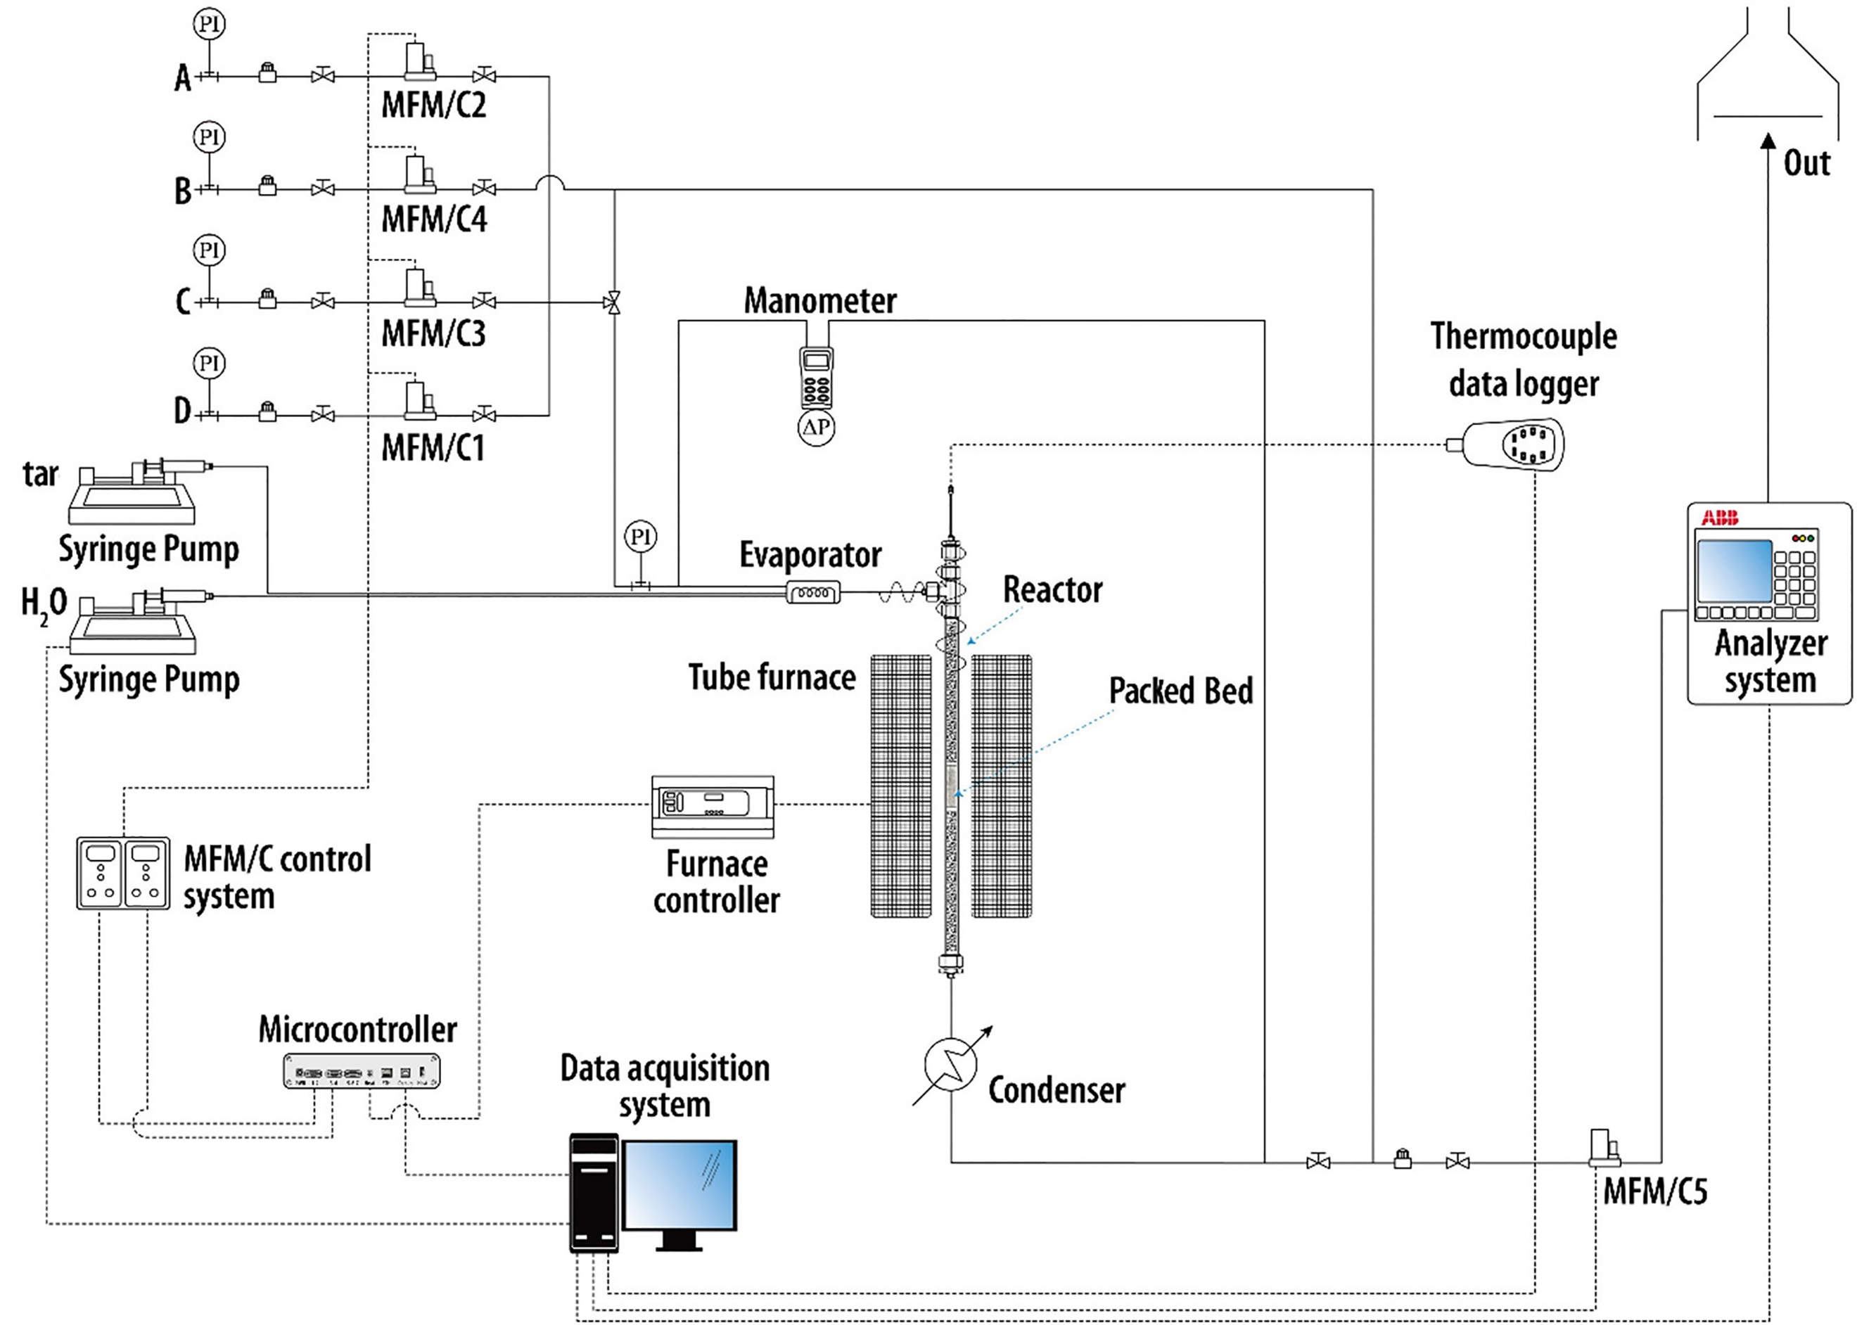
Figure 1: Experimental test rig
A fixed bed reactor (stainless steel pipe, ID= 16 mm; h= 0.5 m) was filled with 0.25 – 0.5 mm grains of the catalyst and heated up by an electric furnace which allows to maintain a stable process temperature. A detailed description of the test rig is reported in a previous work (Tacconi et al., 2022).
Toluene and naphthalene were chosen as tar key compounds, and to simulate the deactivating effect of sulphur compounds, 50 and 100 ppmv of thiophene was added to the toluene/naphthalene solution. The concentration of tar key-compounds was set to 13 g/Nm³_{dry}, while the amount of water injected was that necessary to obtain a molar concentration of steam in the gas equal to 30%. Nitrogen was used as a carrier gas to convey the vaporized fluids (tar and water) to the reactor. The mixture was preheated at 220 °C by electrical resistances. The nitrogen flow rate was chosen to simulate the flow rate of a typical syngas and enable specific quantification of tar conversion due to catalytic steam reforming by analyzing the carbon balance. The outlet stream passes through a double pipe condenser maintained at 0 °C to condense water and condensable hydrocarbons. A mass flow controller was used to measure the dried outlet stream flow rate ($F_{tot,OUT}$).
Online ABB gas analysers were used to determine the composition of the outlet gas in terms of CO, CO₂, H₂ and CH₄ volumetric percentage ($y_{i,OUT}$).
The CO and CO₂ molar flow rates were calculated according to Equation (1):
$F_{i,OUT}=y_{i,OUT}∙F_{tot,OUT}$ $i=CO,{CO}_{2}$ | Eq. (1)
Knowing the gas species flow rate the tar conversion was calculated according to Equation 2:
$X_{C,out}=\frac{\int_{t}{\left(F_{CO,OUT}+F_{{CO}_{2},OUT}\right) dt}}{\int_{t}{F_{C_{tar},IN} dt}}$ | Eq. (2)
Where, $F_{C_{tar},IN}$ is the molar flow rate of carbon entering into the system with tar.
Each tests lasted long enough to reach a steady state and to observe a stable products formation. The conversion was calculated from the data when the steady state was reached (Figure 2).

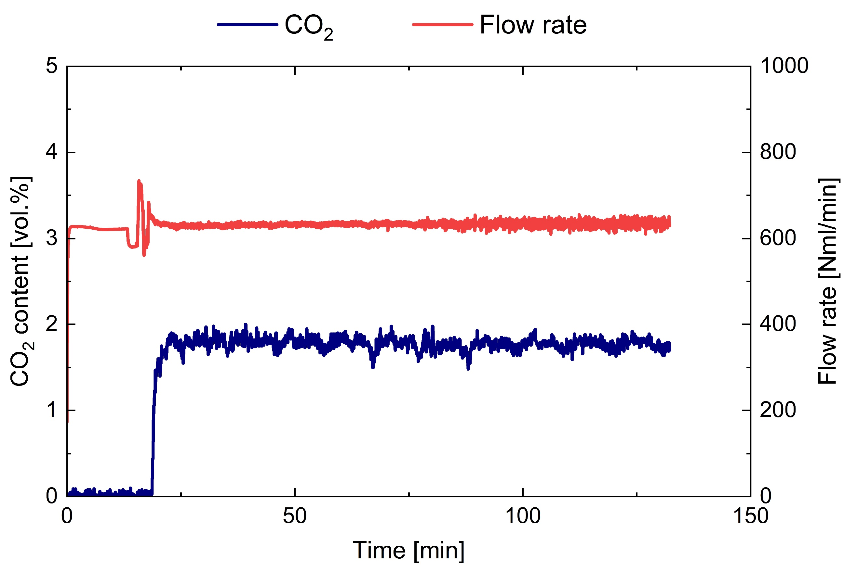
Figure 2: CO₂ content in the outlet stream during the test.
Table 1 and 2 summarize the operating conditions used for the first and second campaign of tests performed on the two catalysts.
In particular, the test conditions of the first campaign are the same for both catalysts, changing the temperature from 700 to 850 °C, H₂S concentration of 50 ppmv and with a GHSV of 6000 h⁻¹.
The GHSV value was calculated according to Equation 3:
$GHSV=\frac{\sum{{\dot{Q}}_{i}}}{V_{bed}}$ $i=H_{2}O,N_{2}, tar$ | Eq. (3)
The value of GHSV was chosen to be close to that expected in a filter candle filled with catalyst (Savuto et al., 2019)
Table 1: Process conditions for the first test campaign to compare the behaviour of the novel catalyst and a commercial one
 | #1 | #2 | #3 | #4 | #5 | #6
Catalyst | Commercial |  |  | C&CS #1050 B
Temperature [°C] | 700 | 750 | 800 | 700 | 750 | 800
GHSV [h⁻¹] | 6000 |  |  | 6000
Tar content [g/Nm³] | 13.7
Thiophene* [ppmv] | 50
* H₂S equivalent

Table 2: Process conditions of the second test campaign on the novel catalyst
 | #7 | #8 | #9 | #10 | #11 | #12
Catalyst | C&CS #1050 B
Temperature [°C] | 700 | 750 | 800 | 650 | 700 | 750
GHSV [h⁻¹] | 13000 |  |  | 6000
Tar content [g/Nm³] | 13.7
Thiophene* [ppmv] | 50 |  |  | 100
* H₂S equivalent

  - Results and discussion
Figure 3 shows the comparison between the tar conversion obtained with the new catalyst and the commercial one. The conversion efficiency of the inlet hydrocarbons for the latter decreases rapidly with temperature, resulting in a 92% conversion at 800°C, which decreases to 70% at 700°C. This behaviour is attributed to inhibitory effects caused by the presence of H₂S in the syngas, as reported in the literature (Binte Mohamed et al., 2022).
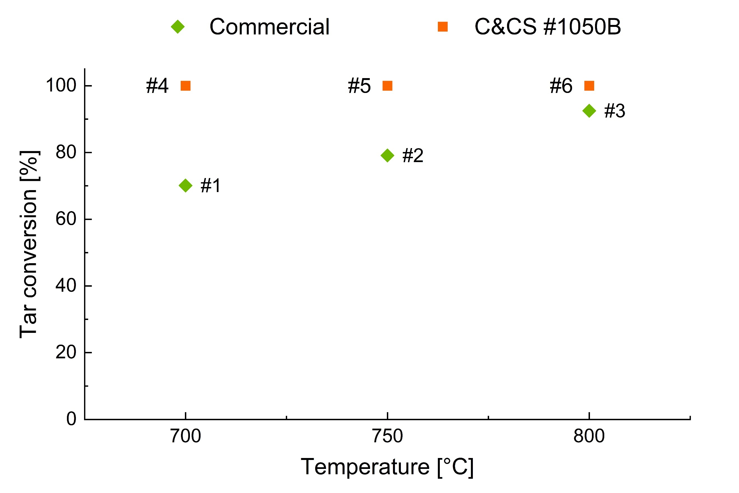
Figure 3: Tar conversion performance as a function of temperature (Tests #1 to #6: tar content = 13.7 g/Nm³; H₂S_{eq} = 50 ppmv; GHSV = 6000 h⁻¹).
In contrast, the new catalyst demonstrates greater efficiency. Notably, it consistently achieves a 100% conversion rate in each test, without being affected by any sulphur inhibition effects. This highlights the independence of its conversion performance from temperature under the tested process conditions. This behaviour can be explained by the relatively high surface area of C&CS #1050 B, that was adjusted in the inventive production process by synthesizing a high surface area support material and adjusting a high NiO loading at a high NiO dispersion. In the presence of 50 ppmv H₂S, where H₂S adsorption on Ni active sites can occur to a certain extent to achieve an equilibrium, C&CS #1050 B evidently provides still a remaining sufficiently high active surface area to convert 100% of the tars.
Further tests were conducted to assess the performance of the new catalyst under worst conditions by increasing the GHSV and the H₂S content.

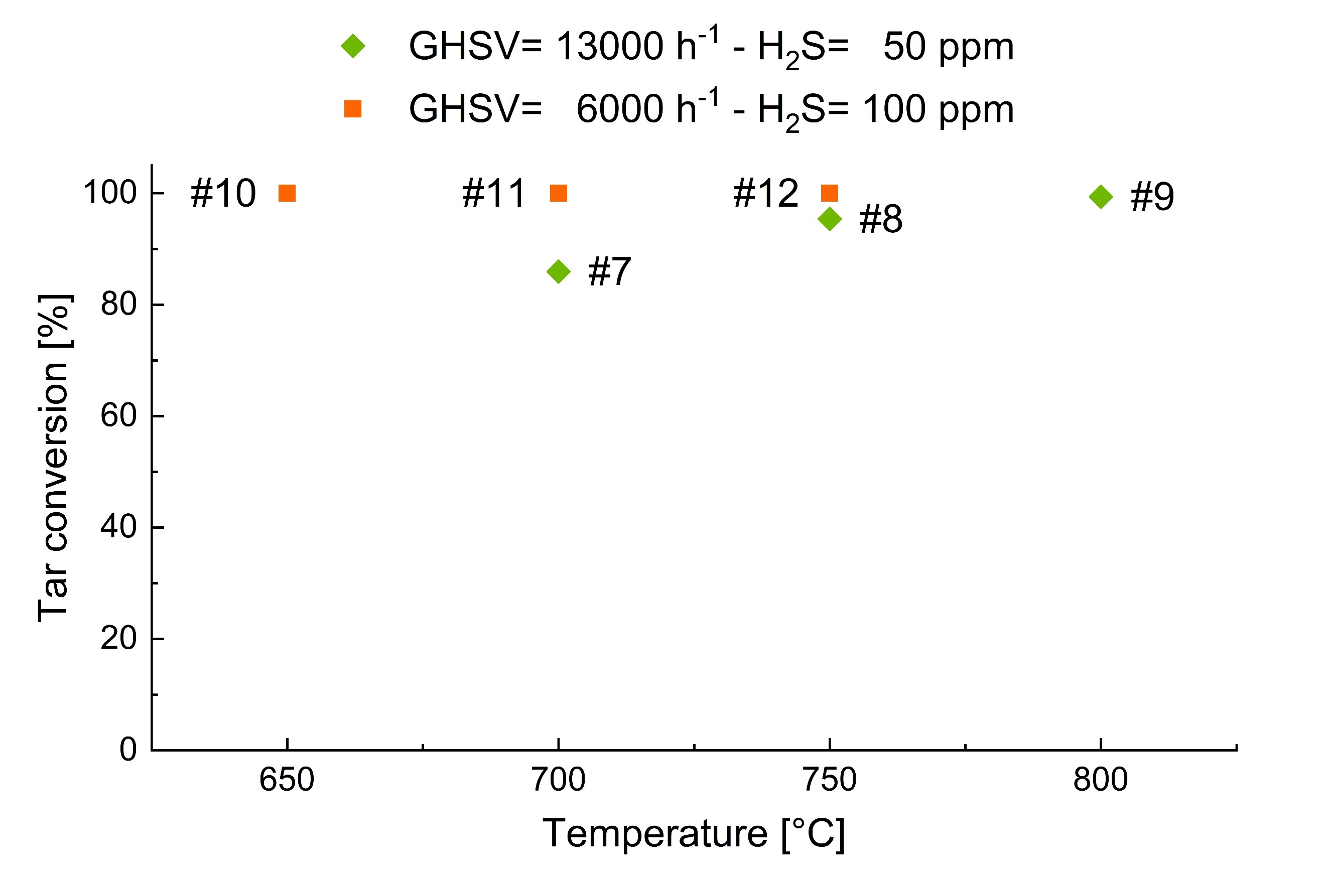
Figure 4. Novel catalyst performance as function of temperatures at different conditions (Tests #7, #8 and #9: tar content = 13.7 g/Nm³, H₂S_{eq} = 50 ppmv; GHSV = 13000 h⁻¹; Tests #10, #11 and #12: tar content = 13.7 g/Nm³, H₂S_{eq} = 100 ppmv; GHSV = 6000 h⁻¹)
More than doubling the GHSV leads to a reduced catalyst performance due to the reduced residence time as reported in Figure 4. Nevertheless, the obtained conversion rates remain higher than those achieved by the commercial catalyst, reaching nearly 100% at 800 °C and exceeding 95% at 750 °C.
Figure 4 also presents the test results with 100 ppmv H₂S equivalent. The conversion is consistently close to 100 %, showing no deactivation effects even at a relatively low temperature of 650 °C.
Furthermore, the composition and flow rate of the outgoing gas remained sufficiently stable throughout the tests, without evidence of catalyst deactivation effects attributed to carbon deposition. This result aligns with expectations considering the high S/C ratio used in the test (approximately 19) (Cao et al., 2018).
These results represent a substantial improvement in reforming at a relatively high tar content. Previous tests on the conversion of tar model compounds with a commercial catalyst have shown that the presence of 100 ppm H₂S requires a temperature of 850 °C to achieve 100% conversion, and 60 % conversion was achieved at 800 °C (Tacconi et al., 2022).
The enhanced tar reforming activity exhibited by the novel catalyst can be attributed to the increased BET surface area (approximately four times greater than that of conventional tar steam reforming catalysts) and the increase in density of NiO. This improved quality is further demonstrated by the high CO₂ content in the product gas, indicating a high water gas shift activity of the catalyst.

  - Conclusions
In this work, a novel Ni-based catalyst (C&CS #1050 B) was tested in a laboratory scale packed-bed reactor to assess its performance under different process conditions. Tar key compounds (naphthalene and toluene) and thiophene (as equivalent H₂S) were used for the steam reforming tests. In particular, a tar content of 13 g/Nm³, two gas hourly space velocities (6000 and 13000 h⁻¹), two typical concentrations of equivalent H₂S (thiophene at 50 and 100 ppmv) and temperatures ranging between 650 and 800 °C were examined.
The preliminary tests with 50 ppmv of thiophene and a GHSV of 6000 h⁻¹ were compared to the results obtained with a commercial catalyst, demonstrating superior performance of the novel catalyst (tar conversion of 100% at each temperature). Furthermore, at increased GHSV, the conversion remained close to 100% at 800 °C and higher than 95% at 750 °C. A significant improvement in tar reforming compared to a commercial catalyst was observed at 100 ppmv H₂S, achieving a 100 % conversion rate even at 650 °C.
Future activities will focus on evaluating the performance of this novel catalyst for tar steam reforming in a real biomass gasification environment. Filter candles filled with the catalyst will be tested in a pilot-scale biomass gasifier.

References
Asadullah M., 2014, Biomass gasification gas cleaning for downstream applications: A comparative critical review, Renewable and Sustainable Energy Reviews, 40, 118–132.
Binte Mohamed D. K., Veksha A., Ha Q. L. M., Chan W. P., Lim T. T., Lisak G., 2022, Advanced Ni tar reforming catalysts resistant to syngas impurities: Current knowledge, research gaps and future prospects, Fuel, 318, 123602.
Cao J. P., Ren J., Zhao X. Y., Wei X. Y., Takarada T., 2018, Effect of atmosphere on carbon deposition of Ni/Al2O3 and Ni-loaded on lignite char during reforming of toluene as a biomass tar model compound, Fuel, 217, 515–521.
CE project MEMBER, 2022, cordis.europa.eu/project/id/760944.
Depner H., Jess A., 1999, Kinetics of nickel-catalyzed purification of tarry fuel gases from gasification and pyrolysis of solid fuels, Fuel, 78, 1369–1377.
Gholamian E., Zare V., Mousavi S. M., 2016, Integration of biomass gasification with a solid oxide fuel cell in a combined cooling, heating and power system: A thermodynamic and environmental analysis; International Journal of Hydrogen Energy, 41(44), 20396–20406.
Heidenreich S., Foscolo P. U., 2015, New concepts in biomass gasification. Progress in Energy and Combustion Science, 46, 72–95.
IEA, 2021, Key World Energy Statistics, IEA, Paris. www.iea.org/reports/key-world-energy-statistics-2021.
Ma L., Verelst H., Baron G. V., 2005, Integrated high temperature gas cleaning: Tar removal in biomass gasification with a catalytic filter, Catalysis Today, 105(3–4), 729–734.
Ouweltjes J. P., 2019, “Report summarising the literature review” for Selection of Representative Syngas Compositions including Organic and Inorganic Contaminants, Deliverable 3.2, BLAZE, European Project No. 85284.
Papa A. A., Di Carlo A., Rapagnà S., 2022, Biomass as a Renewable Source to Produce Synthesis Gas by Catalytic Gasification Process, Chemical Engineering Transactions, 92, 295–300.
Papa A. A., Savuto E., Di Carlo A., Tacconi A., Rapagnà S., 2023, Synergic Effects of Bed Materials and Catalytic Filter Candle for the Conversion of Tar during Biomass Steam Gasification, Energies, 16, 595.
Savuto E., Di Carlo A., Steele A., Heidenreich S., Gallucci K., Rapagnà S., 2019, Syngas conditioning by ceramic filter candles filled with catalyst pellets and placed inside the freeboard of a fluidized bed steam gasifier, Fuel Processing Technology, 191, 44–53.
Tacconi A., Savuto E., Di Giuliano A., Di Carlo A., 2022, Laboratory-Scale Study of Nickel-Catalyst Pellets Performance for Tar Steam Reforming Obtained from Biomass Gasification, Chemical Engineering Transactions, 92, 655–660.
UNFCCC, 2015, Paris Agreement, 21st Conf Parties Paris Climate Change Conference - November 2015, unfccc.int/process-and-meetings/the-paris-agreement/the-paris-agreement.

